***Lab 3 – Persist Data / State Management***

*Following are the steps:*

*Create a New Empty MVC Application > Add a Controller named DefaultController*

*Based on time we want to greet the user. Write the following code snippet in the Index Method of the DefaultController*

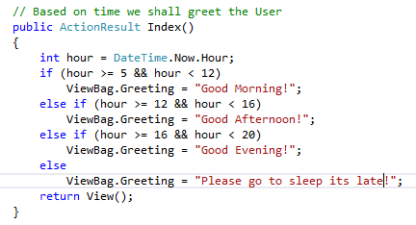

*Add View > Right click on the Action Method > Click on Add View*

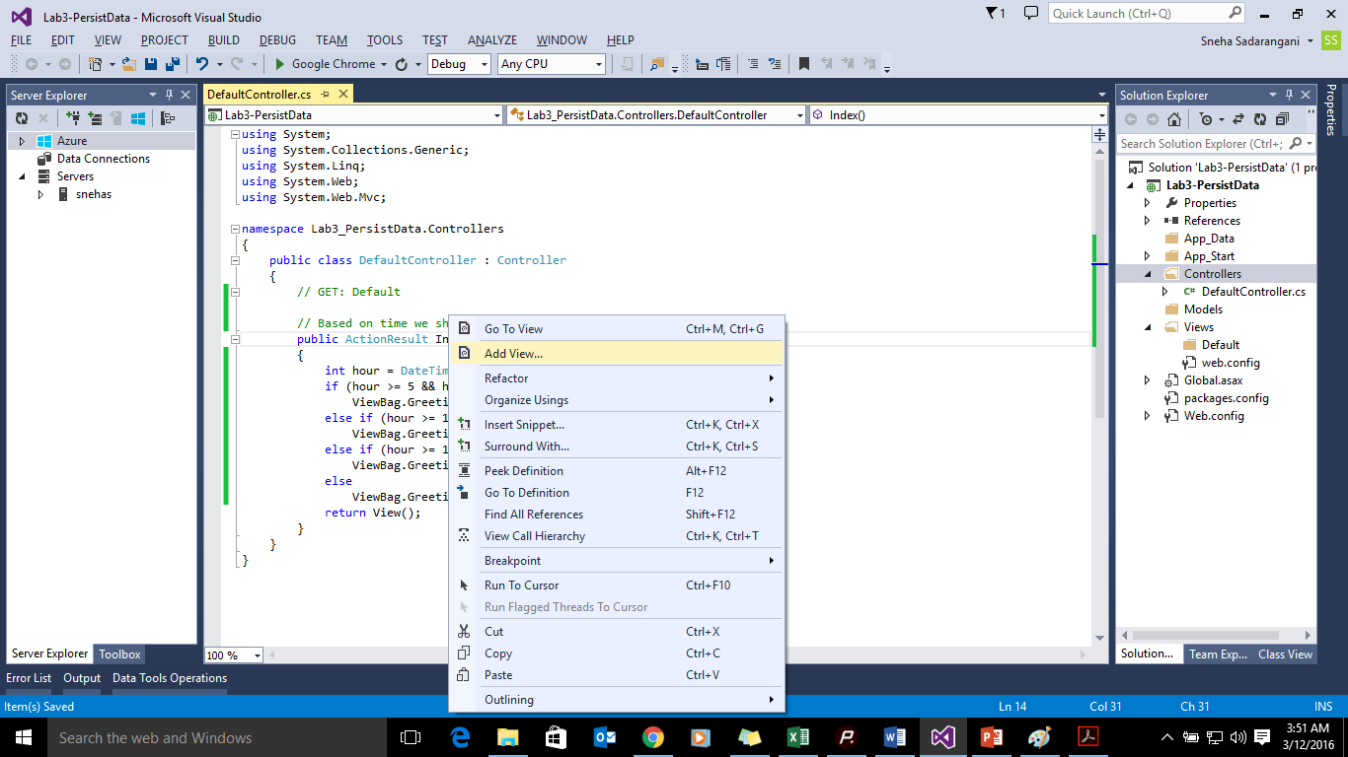

*Add the following code snippet in the View..*

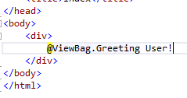

*Understanding the difference between all the types of data persistency mechanism*

*Add the following Action Method in DefaultController:*

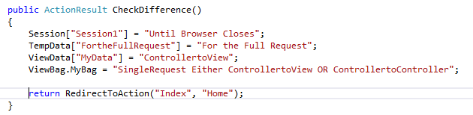

*Add empty controller named HomeController. Add the following code snippet in the Index Action Method:*

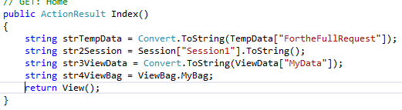

*Right click on Index action Method of HomeController > Add View. Add the following code snippet to the View:*

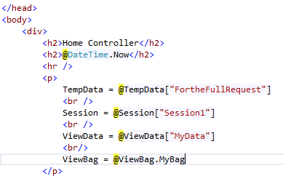

*Run the code in the Debug mode. Enter the following URL:*

**

*Check the Watch Window:*

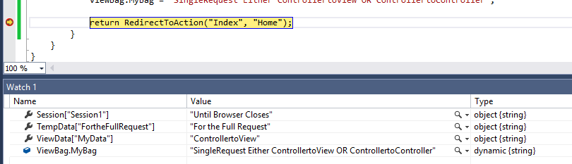

*Press F5 for Next step*

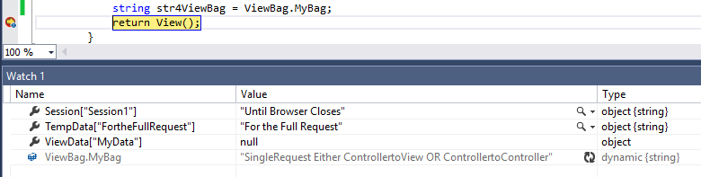

*After Browser load*

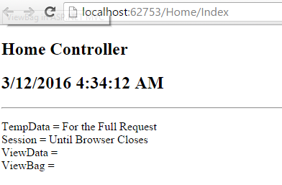

*Now testing the Second Request from the Same Page. Make the following changes:*

*Add two new ViewBag and ViewData properties in HomeController –Index method*

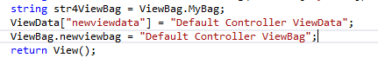

*Add the same in the View also:*

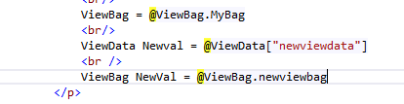

*Add a Hyperlink which will redirect on the same Page*

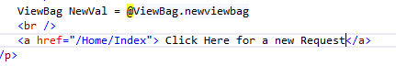

*Now let’s Run the application:*

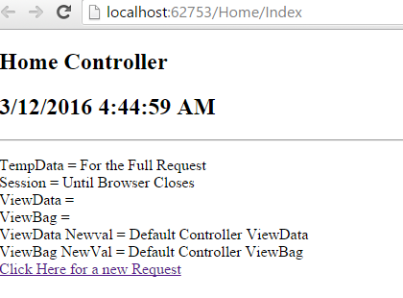

*Now click on the Hyperlink:*

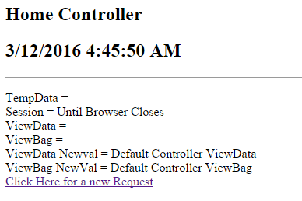

*This is to simulate a fresh request. All the other variables goes off only session variables persist and freshly set ViewData and ViewBag properties*